Teaching and Learning Resources
Devki Maaveer Homoeopathic Medical College & Research Hospital to attain efficiency in academics an innovative teaching and learning resources is implementing. The facilities of which are specified here:
- Transmission of traditional class rooms to learning halls enabling with advanced ICT tools.
- Number of computers : 15 ( with all accessories)
- Projector (LCD)-2
- Over head projector-1
- Smart class room-1
- JIO WI-FI-1, Jio router and BSNL Broadband facilities.
- Demonstration rooms are also enabled with WI-FI/ LAN facilities to elevate learning efficiency.
- Herbal garden with more than 500 medicinal plants in flower pots and more than 1000 medicinal trees are maintaining by the herbal garden in charge Dr. J.S.Tiwari (Ayeruvedacharya).
- Providing seminar halls/ Conference hall with a capacity of 300 students.
- Auditorium available with a seating arrangement of more than 300 capacities.
- Models/ Specimen/Charts of various types are maintaining in all the departments wherever needed as a teaching and learning resources.
- Laboratories are available with all infrastructure like: Anatomy (Cadavar & Museum), Physiology, Biochemistry, Biochemistry, Microbiology, Pathology, Homoeopathy Pharmacy, Forensic Medicine etc..
- E- Library Facilities are available for learning and teaching process.
- ICT room available with computers of 15 in number with all necessary accessories.
- IPD and OPD facilities are available in the hospital related to homoeopathy

CLASS ROOMS ONE TO SIX
GOOD VENTILATED CLASS ROOMS WITH A SEATING ARRANGEMENT OF MORE THAN 50.

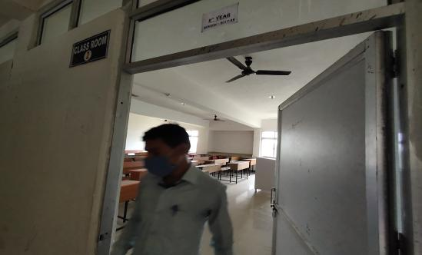
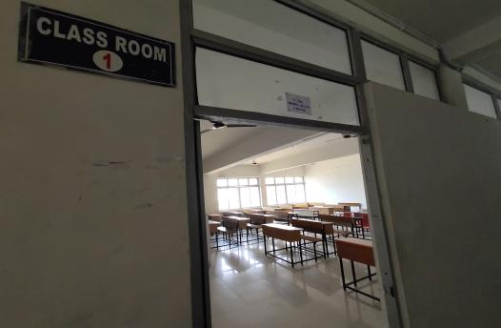

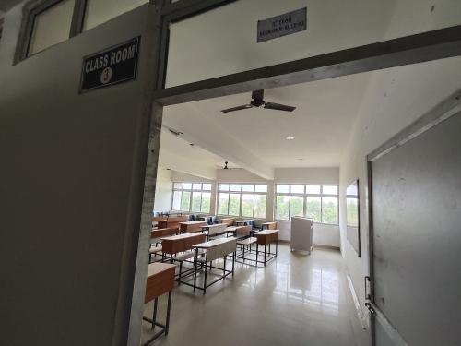
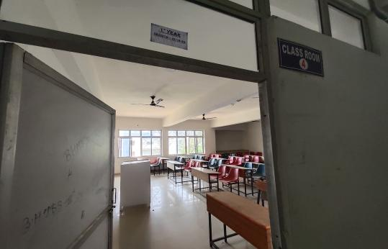

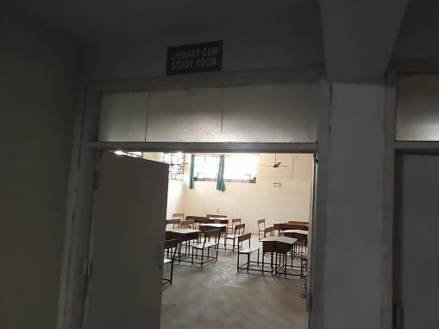
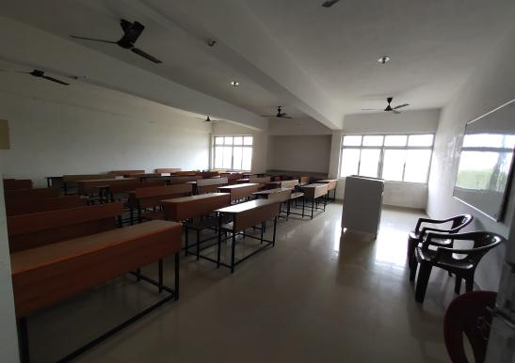

ICT FACILITIES
STUDENTS CAN ALSO UTILIZE THE ICT TOOLS THAT ARE AVAILABLE AS LEARNING RESOURCES.
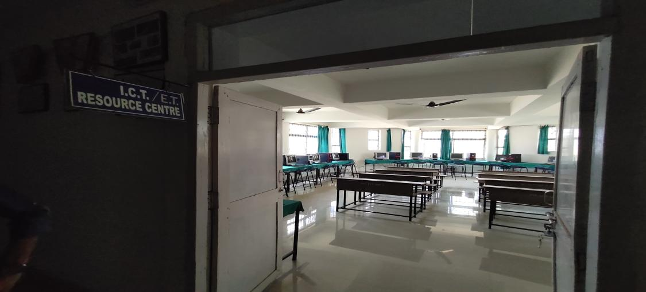

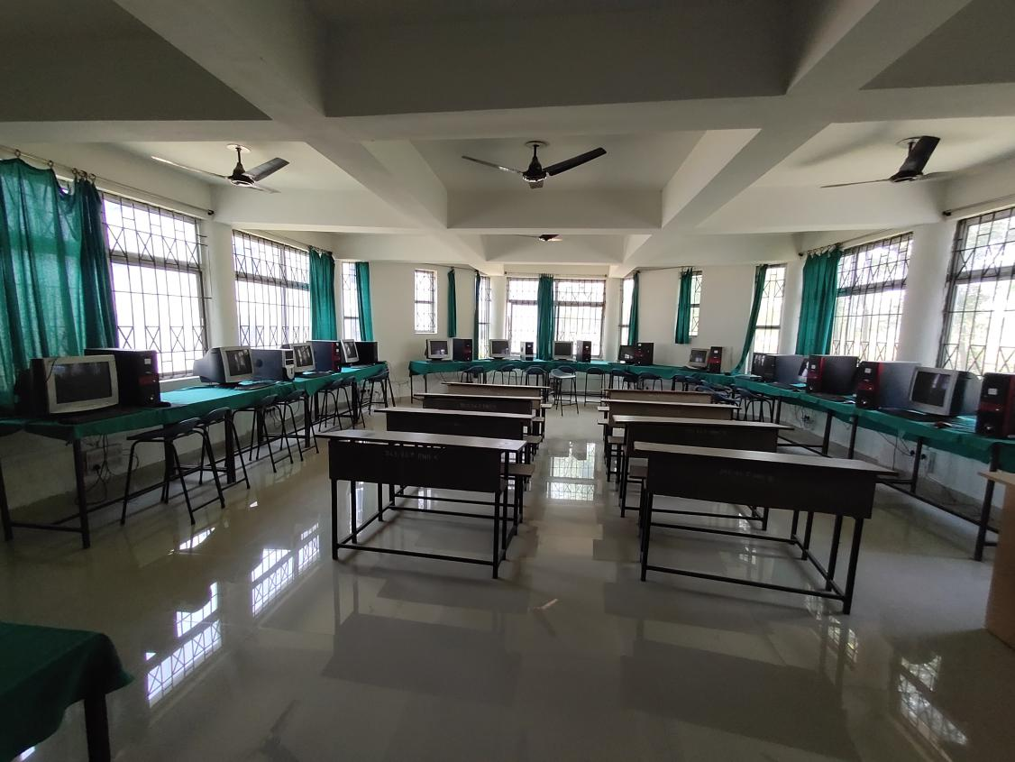

Herbal Garden
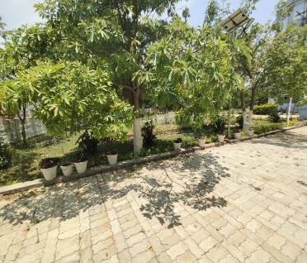
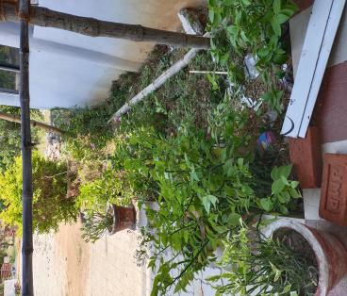
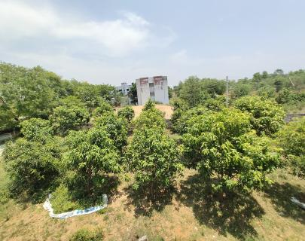

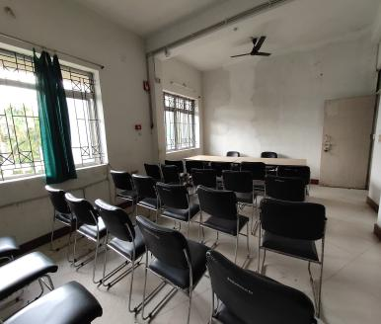
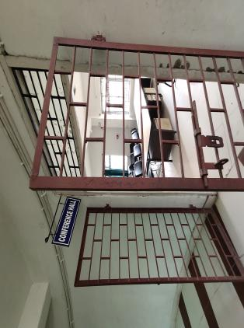
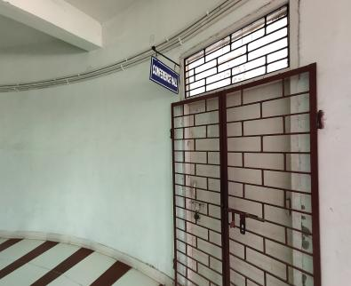
Seminar/ Conference Hall

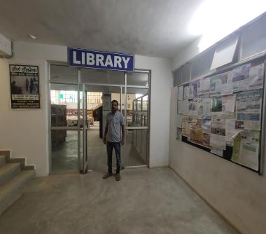
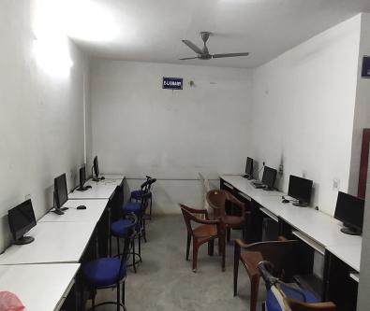
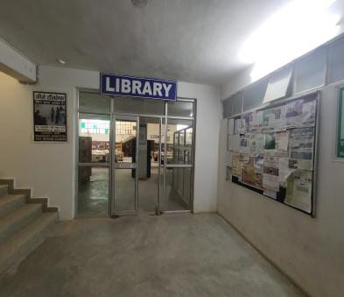
Library Cum Reading Room

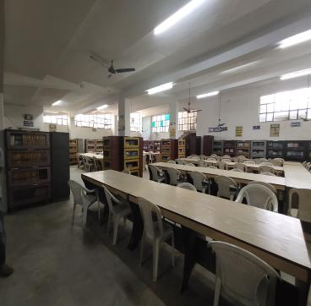
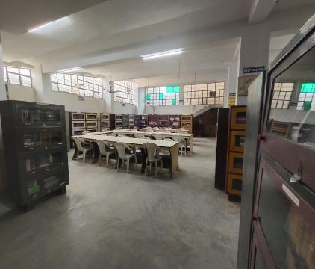

OPD AND IPD

